Guidelines for Superconductivity News Forum Authors
Author1¹, Author2², Author3³
¹Institute One – University One
Address One - City One - Country One
²Institute Two - University Two
Address Two - City Two - Country Two
³Institute Three - University Three
Address Three - City Three - Country Three
corresponding-author@somewhere.com
Abstract— This template defines the layout and fonts to be used in articles written for the Superconductivity News Forum (SNF). In this section, you should insert the abstract of your work. The abstract should be a single paragraph, which contains no less than 40 and no more than 200 words.
Keywords (Index Terms)— Keyword 1, keyword 2, keyword 3, keyword 4.
Received: Month, Day, Year; Accepted: Month, Day, Year. Reference No. XX; Category(ies) XXX.
Possible journal reference: first line.
Possible journal reference: second line.

GENERAL INFORMATION

The concept of the online News Forum aims at filling the gap between peer-reviewed scientific publications and the latest news disseminated by commercial newsletters. This means that personal opinions and controversial statements are acceptable, albeit subject to editorial review and possible discussion.
Please read carefully the instructions cited in this template. Failure to follow these guidelines may result in long delays in posting on line or rejection.
All full papers submitted to the SNF should be written in satisfactory English. Acceptable are the following versions of English: Australian, New Zealand, South African, UK and USA. The last (USA) is preferred. The format paper should be A4 or 11” x 8.5” with single column. In headings, all nouns, verbs, adjectives and adverbs must start with a capital letter.
In this template, just replace the present text by your own (including title, authors, etc.). Footnotes to the page text are permitted at its bottom and should be in numerical order (Arabic number superscript) throughout the text. Times New Roman, corresponding Greek symbols and mathematical symbols are the fonts to be used. All symbols must be in italics, except the Greek ones, but sub- and superscripts are not. Heading orphans at the bottom of page are not permitted. Orphans figures with caption on the following page are not permitted. In the LaTeX template the users are free to use the normal commands to create equations and tables environments. In the WORD template, the use of the "equation" environment (the Math Editor) is preferable to create equations. All equations must numbered by Arabic numerals in brackets placed on the right side of page, e.g., (1), (2), (3) as showed below.

 | $$A= \int_{Y=0}^{1}{\frac{∂^{2}θ\left(β_{m},Y,τ\right)}{∂Y^{2}}}Y\left(γ_{n},Y\right)dY-\int_{Y=0}^{1}{β_{m}^{2}}θ\left(β_{m},Y,τ\right)Y\left(γ_{n},Y\right)dY$$ | (1)

  - Subsections

Section headings are centered and numbered by Roman numerals (I, II, III, heading in bold capitals); subsection headings must be numbered by letters (A., B., C, heading in Italics).

Sub-subsections
Sub-subsections are not recommended. However if used, then no numbering (heading in Italics).

TABLES, FIGURES AND CAPTIONS

Table I illustrates an example of table layout.

Table I. Table Title
Model | Properties | c and λ
MA | hot | constant
MB | cold | constant
MC | warm | temperature dependent

The tables must be integrated into the text. When cited in the text, write "Table...", starting with capital letter. Try to avoid the use of colored or shaded backgrounds, and avoid thick, doubled, or unnecessary framing lines. When reporting empirical data, do not use more decimal digits than warranted by precision and reproducibility. Table caption must be placed above the table (see Table I), with “Table...” in bold.
All images and illustrations can be in black-and-white or gray tones, or in color. The image resolution on paper should be about 600 dpi for black-and-white and color images, and 150-300 dpi for grayscale images. Do not include images with excessive resolution, as they may take hours to print, without any visible difference in the result.
Figures must also be integrated into the text. Figure caption is placed below figure. When cited in the text, write "Figure...", starting with capital letter. In the caption, the abbreviation "Fig." should be used.

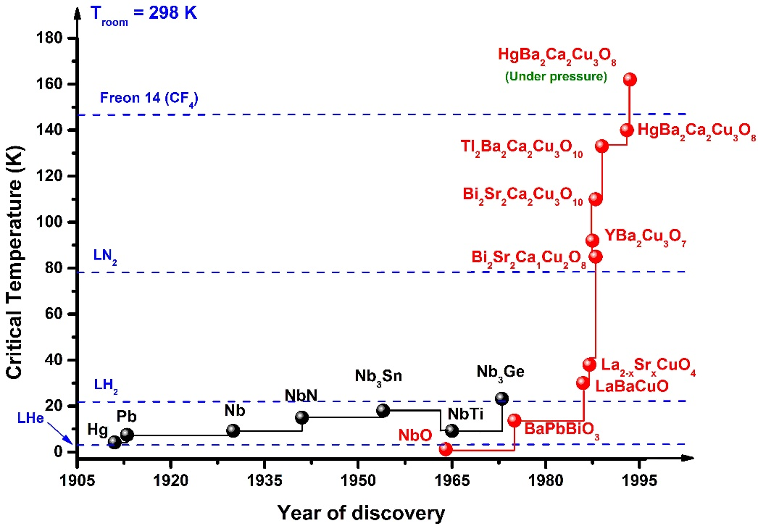
Fig. 1. Figure example: critical temperature of discovered superconducting materials over the years.

The Encapsulated PostScript (EPS) or Portable Document Format (PDF) is the preferred graphics format for LaTeX documents. For WORD documents, the JPG format is preferred.

REFERENCES

The references must be listed at the end of the document. Examples of listing style: article [1], books [2], conferences [3], master and phd thesis [4], technical reports [5] unpublished papers [6] and URL links [7]. See next page for example.
The authors are encouraged making use of the SNF style when making use of the LaTeX template.

ACKNOWLEDGEMENTS

The sponsor and financial support acknowledgment goes here. Avoid expressions such as "One of us (S.B.A.) would like to thank ...". Instead, write "S.B.A. thanks ...".

III. REFERENCES

[1] B. Douine, D. Netter, J. Lévêque and A. Rezzoug, “Ac losses in a bscco current lead: Comparison between calculation and measurement”, IEEE Trans. Appl. Supercond., 12 (No. 1), 1603 - 1606 (2002).
[2] J. C. Butcher, Numerical Methods for Ordinary Differential Equations, John Wiley & Sons, 2 edn., (2008), pp. 482.
[3] M. O. Rikel, S. Elschner, A. Hobl and J. Bick, “Current Transfer Mechanisms in Polycrystalline Forms of Bi2212. Effect of Oxygen Contents on J_{c} (77K,sf)”, in: “Superconductivity Centennial Conference EUCAS/ICEC/ICMC 2011”, Den Haag, Netherlands, Poster presentation (2011).
[4] D. Colangelo, Modelling of 2G HTS Coated Conductors for Fault Current Limiter Applications, Ph.D. thesis, Ecole Polytechnique Fédérale de Lausanne (2013).
[5] M. Waldron, M. Escoto, N. Lamaítre, L. Colla and A. Carvalho, “Overstress Criteria for Transmission Equipment”, Tech. rep., Very Large Power Grid Operators (2012).
[6] W. T. B. de Sousa and M. Noe, “The Alternating Direction Implicit for Simulations of SFCL”, IEEE Trans. Appl. Supercond., In press.
[7] “Guidelines for superconductivity news forum authors”, URL http://snf.ieeecsc.org/pages/guidelines-superconductivity-news-forum-snf-authors, May (2018).

ACKNOWLEDGEMENTS

The sponsor and financial support acknowledgment goes here. Avoid expressions such as "One of us (S.B.A.) would like to thank ...". Instead, write "S.B.A. thanks ...".

