Guidelines for Superconductivity News Forum Authors (Highlights)

Author1¹, Author2², Author3³

¹Institute One – University One - Address One - City One - Country One.
²Institute Two - University Two - Address Two - City Two - Country Two.
³Institute Three - University Three - Address Three - City Three - Country Three.

Email: corresponding-author@somewhere.com

Month Day, Year (HPXX). The concept of the online News Forum aims at filling the gap between peer-reviewed scientific publications and the latest news disseminated by commercial newsletters. This means that personal opinions and controversial statements are acceptable, albeit subject to editorial review and possible discussion.
Please read carefully the instructions cited in this template. Failure to follow these guidelines may result in long delays in posting on line or rejection.
All full papers submitted to the SNF should be written in satisfactory English. Acceptable are the following versions of English: Australian, New Zealand, South African, UK and USA. The last (USA) is preferred. The format paper should be A4 or 11" x 8.5" with single column.
Allowed are maximum two pages of text with two figures inclusive captions. To save page space, figures can have captions on the left or right side of a figure, as shown in figure 1.

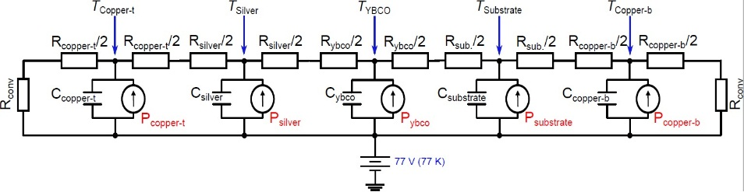 | Fig. 1. Developed electrical network to reproduce the thermal behavior of some HTS devices. A figure with its caption side by side.

All images and illustrations can be in black-and-white or gray tones, or in color. The image resolution on paper should be about 600 dpi for black-and-white and color images, and 150-300 dpi for grayscale images. Do not include images with excessive resolution, as they may take hours to print, without any visible difference in the result. Figures must also be integrated into the text. Figure caption is placed below figure. When cited in the text, write "Figure...", starting with capital letter. In the caption, the abbreviation "Fig. .." should be used printed in bold. The Encapsulated PostScript (EPS) or Portable Document Format (PDF) is the preferred graphics format for LaTeX documents. For WORD documents, the JPG format is preferred.
References can spill over to the third page or be entirely on it. There is no limit to the number of references. No section headings are allowed, except for "References". The references must be listed at the end of the document. Examples of listing style: article [1], books [2], conferences [3], master and PhD thesis [4], technical reports [5] unpublished papers [6] and URL links [7].
The authors are encouraged making use of the SNF style when making use of the LaTeX template.
In this template, just replace the present text by your own (including title, authors, etc.). Footnotes to the page text are permitted at its bottom and should be in numerical order (Arabic number superscript) throughout the text. Times New Roman, corresponding Greek symbols and mathematical symbols are the fonts to be used. All symbols except the Greek ones must be in italics, but sub- and superscripts are not. Orphans figures with caption on the following page are not permitted. In the LaTeX template, the users are free to use the normal commands to create equations and tables environments. In the WORD template, the use of the "equation" environment (the Math Editor) is preferable to create equations.
The tables must be integrated into the text. When cited in the text, write "Table...", starting with capital letter. Try to avoid the use of colored or shaded backgrounds, and avoid thick, doubled, or unnecessary framing lines. When reporting empirical data, do not use more decimal digits than warranted by precision and reproducibility. Table caption must be placed above the table, with “Table …” printed in bold.

References
[1] B. Douine, D. Netter, J. Lévêque and A. Rezzoug, “Ac losses in a bscco current lead: Comparison between calculation and measurement”, IEEE Trans. Appl. Supercond., 12 (No. 1), 1603 - 1606 (2002).
[2] J. C. Butcher, Numerical Methods for Ordinary Differential Equations, John Wiley & Sons, 2 edn., (2008), pp. 482.
[3] M. O. Rikel, S. Elschner, A. Hobl and J. Bick, “Current Transfer Mechanisms in Polycrystalline Forms of Bi2212. Effect of Oxygen Contents on J_{c} (77K,sf)”, in: “Superconductivity Centennial Conference EUCAS/ICEC/ICMC 2011”, Den Haag, Netherlands, Poster presentation (2011).
[4] D. Colangelo, Modelling of 2G HTS Coated Conductors for Fault Current Limiter Applications, Ph.D. thesis, Ecole Polytechnique Fédérale de Lausanne (2013).
[5] M. Waldron, M. Escoto, N. Lamaítre, L. Colla and A. Carvalho, “Overstress Criteria for Transmission Equipment”, Tech. rep., Very Large Power Grid Operators (2012).
[6] W. T. B. de Sousa and M. Noe, “The Alternating Direction Implicit for Simulations of SFCL”, IEEE Trans. Appl. Supercond., In press.
[7] “Guidelines for superconductivity news forum authors”, URL http://snf.ieeecsc.org/pages/guidelines-superconductivity-news-forum-snf-authors, April (2018).

